Activity 3.1: Planning an app (Part 2)
You have decided what your app is about, what it will do and how it will work. Now, before you begin coding, you need to write an algorithm for your app.
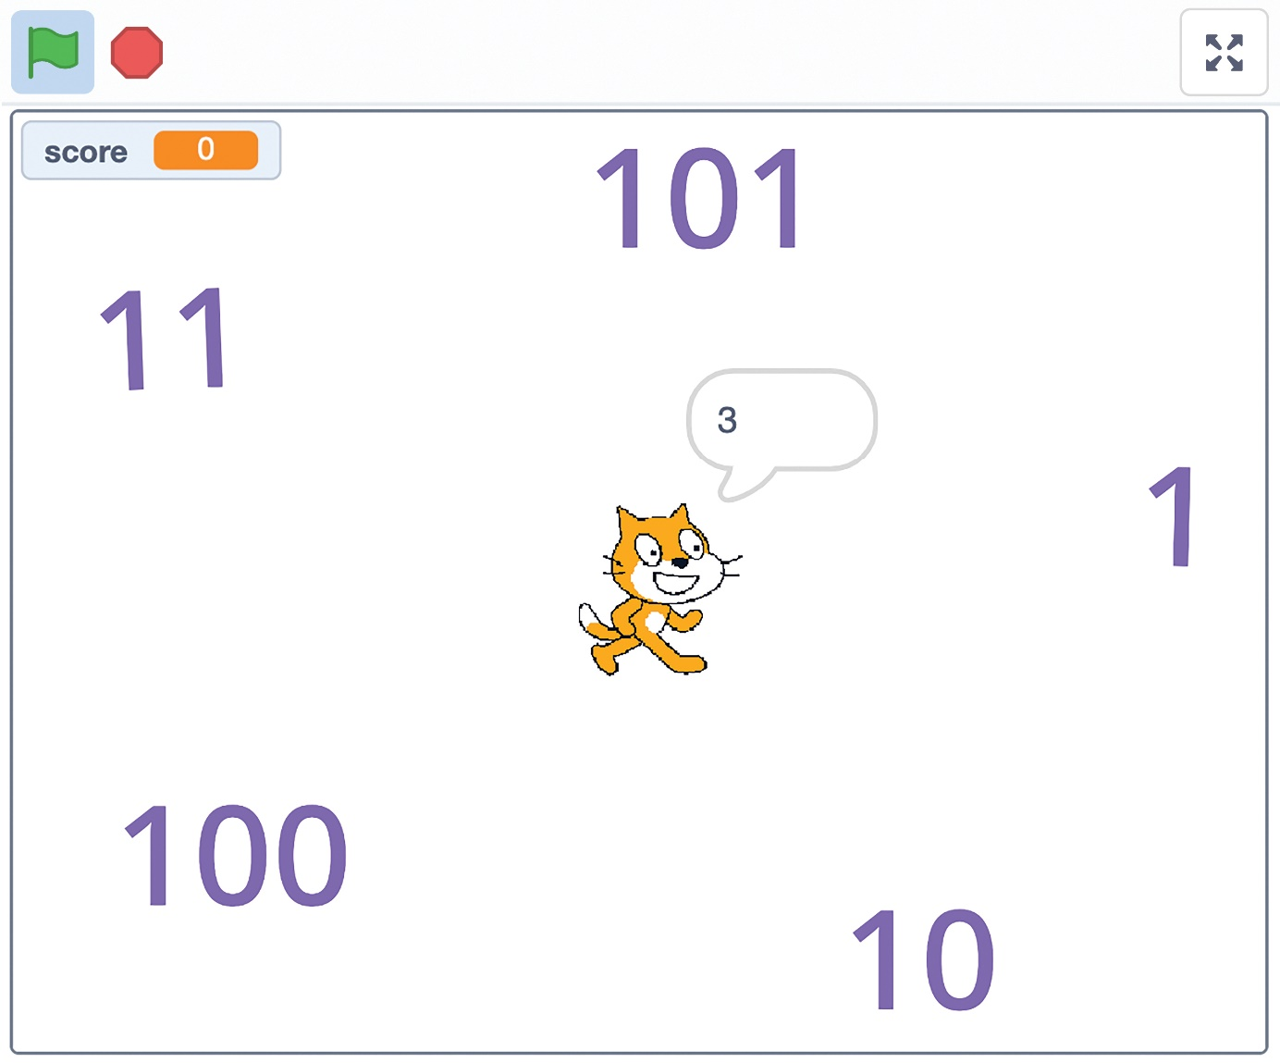
For example, an algorithm for a game in which the user has to click on the binary number equivalent to the denary number the cat calls out might start off like this.
- The user clicks on the green flag to start the game.
- The score variable is set to 0.
- Five binary numbers are displayed on screen.
- The cat calls out a denary number.
- The user clicks on a binary number.
Use the space on the next page to write your algorithm. You can write your algorithm using text or as a flow diagram.

